**Advanced SQL Assignment**

**Assignment 5**

**Question:**

You are given a table, *BST*, containing two columns: *N* and *P,* where *N* represents the value of a node in *BST*, and *P* is the parent of *N*.

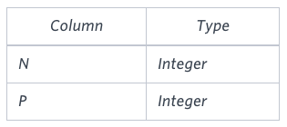

Write a query to find the node type of *BST* ordered by the value of the node. Output one of the following for each node:

* *Root*: If node is root node.
* *Leaf*: If node is leaf node.
* *Inner*: If node is neither root nor leaf node.

**Sample Input**

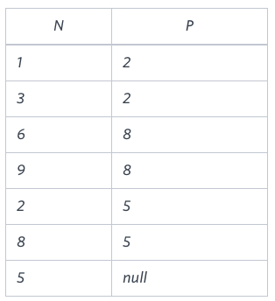

**Sample Output**

1 Leaf  
2 Inner  
3 Leaf  
5 Root  
6 Leaf  
8 Inner  
9 Leaf

**Explanation**

The *BST* below illustrates the sample:

